Pipeline project

1. Install JDK 8

> sudo apt install openjdk-8-jdk openjdk-8-jre

2. To switch With Java Version

> sudo update-alternatives --config java

>choose option 0,1,2,3

> check java version

- java -version

1. Select piplineproject

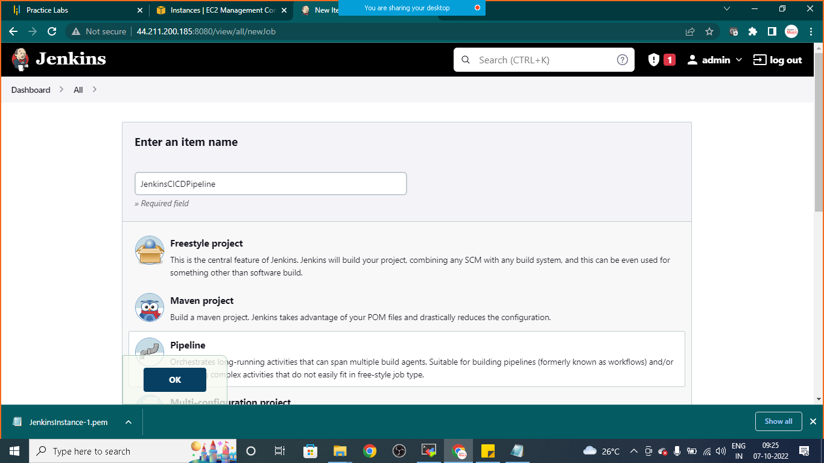

1. Give description

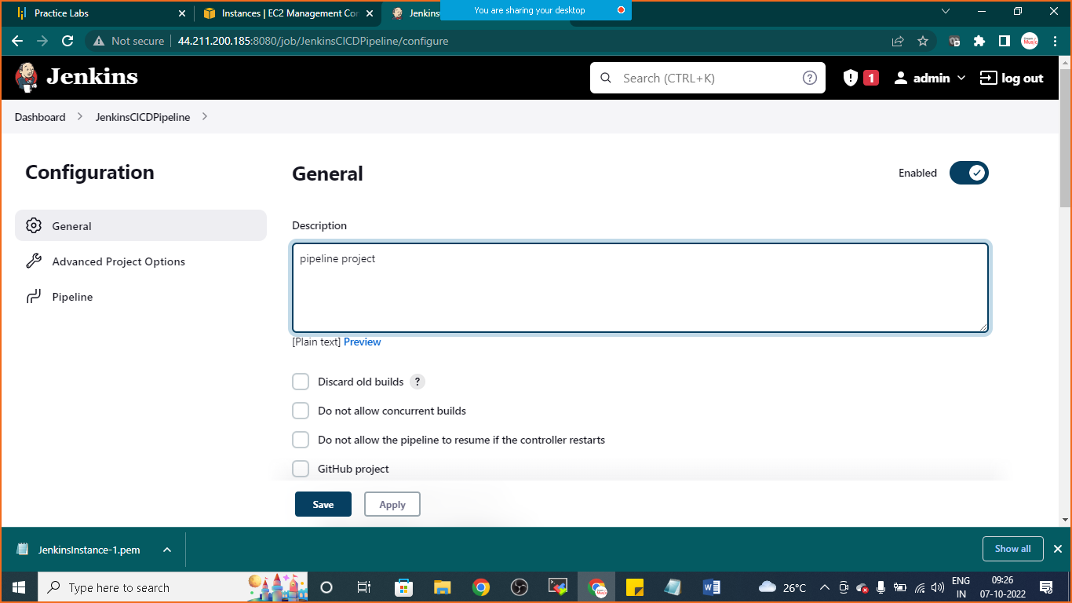

1. Give github link

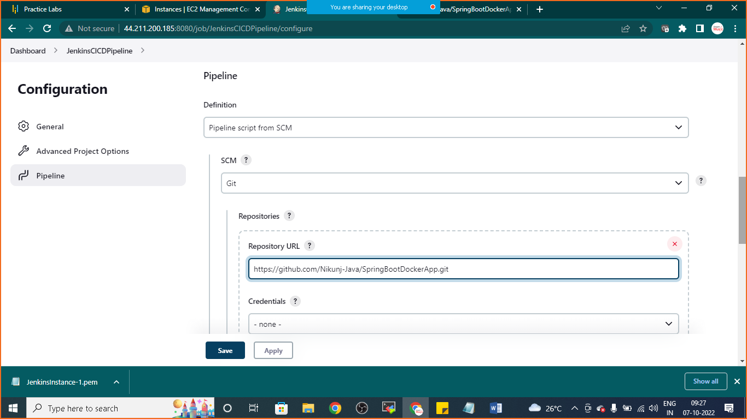

Link: <https://github.com/Nikunj-Java/SpringBootDockerApp.git>

Click on apply and save

If you are getting permission denied error run below code

---to deal with permission denied error----

* sudo chmod 777 /var/run/docker.sock

again click on buid

if container is deployed successfully you can check the same on docker

goto> mobax-term and run below code

* sudo docker images
* Sudo docker container ls